A Project Report on
FinIntel
AI Driven Credit & Fraud Intelligence Platform
By
Mr Jagdish Dilip Chavan (20250202022)
MCA – I, SEM – I
2025-26
To
Savitribai Phule Pune University, Pune

In Partial Fulfilment of the Degree of
Master in Computer Application (M. C. A.)

Under The Guidance Of
Prof. Megha Mane

Suryadatta Group of Institute, Pune

Suryadatta Institute of Business Management and Technology (SIBMT)

CERTIFICATE

This is to certify that Mr Jagdish Dilip Chavan, has successfully completed his/her project work entitled “FinIntel-AI Driven Credit & Fraud Intelligence Platform” in partial fulfilment of MCA – I for the year A.Y. 2025-26. They have worked under our guidance and direction.

Prof. Megha Mane Dr. Manisha Kumbhar
(Project Guide) HoD-MCA, SGI

Examiner 1 Examiner 2

Date:
Place:
Acknowledgment

We are the student of MCA first year. Here by I express our thanks to our project guide for allowing us to do the project on FinIntel AI Driven Fraud Intelligence Platform This project work has been the most exciting part of our learning experience which would be an asset for our future carrier. I would especially like to thank our guide and mentor Prof. Megha Mane, who constantly guided us in developing, pushing us to search for more answers to her numerous questions. Also, I would like to thank Prof. Megha Mane, project coordinators for her support. As a building block of MCA Department, I thank Dr. Manisha Kumbhar, HOD, MCA Department for her continuous support and help. We are grateful to many classmates who contributed their suggestions. Their hard work and examples push us to limits of our capability and encourage us daily.

Thank You

Student Name:
Mr. Jagdish Dilip Chavan

Index
Chapter | Page number
CHAPTER 1: INTRODUCTION
1.1 Existing System | 8
1.2 Need for System | 10
1.3 Operating Environment Hardware and Software | 11
1.4 Brief Description about Technology Used | 13
CHAPTER 2: PROPOSED SYSTEM
2.1 Proposed System (Introduction of system) | 16
2.2 Module specifications (Scope) | 18
2.3 Objectives of System | 21
CHAPTER 3: ANALYSIS & DESIGN
3.1 ERD Diagram | 24
3.2 Use Case Diagrams | 26
3.3 Activity Diagram | 34
3.4 Sequence Diagram | 40
3.5 Class Diagram | 42
3.6 Module Hierarchy Diagram | 43
3.7 Table specifications (Database design) | 45
3.8 Data dictionary | 47
CHAPTER 4: USER MANUAL
4.1 User Interface Screens (Input) | 50
4.2 Output Screens with data | 52
4.3 Data Reports | 56
4.4 Sample program code | 59
4.5 Limitations | 67
4.6 Test Case | 69
Bibliography | 72

CHAPTER: 1 Introduction

1 INTRODUCTION:
The banking and financial services sector is increasingly dependent on data-driven decision systems for credit assessment, fraud monitoring, and operational risk control. Traditional rule-based systems are often limited because they depend on fixed thresholds and manually designed rules, which may fail to capture complex borrower behavior, evolving fraud patterns, and nonlinear relationships in financial data. Recent research has shown that machine learning models such as Random Forest, Gradient Boosting, XGBoost, stacked classifiers, and ensemble-based approaches can improve prediction accuracy in both credit risk assessment and fraud detection tasks [1], [4], [5], [7]. These methods are especially useful in financial applications because they can process large structured datasets, identify hidden patterns, and support faster decision-making.
FinIntel is proposed as a banking risk intelligence platform that combines credit risk prediction, maximum credit amount estimation, fraud detection, management dashboards, authentication, and prediction logging in a single Streamlit-based application. The system is designed to support risk analysts by converting raw customer, bureau, tradeline, enquiry, and transaction details into actionable predictions. For credit risk, the platform uses applicant profile and bureau-related features to predict the approval category and estimate a suitable maximum credit amount. Studies on credit scoring and default prediction indicate that machine learning models, particularly XGBoost, Random Forest, and stacked ensemble approaches, can provide strong performance for credit classification problems and can handle feature interactions more effectively than conventional statistical models [1], [2], [3], [6].
The fraud detection component of FinIntel focuses on identifying suspicious transaction behavior using customer profile information, transaction details, and derived anomaly indicators such as amount-to-average ratio, balance drain percentage, transaction velocity, unusual transaction hour, and new transaction type flags. Research on financial fraud detection has shown that XGBoost and ensemble learning approaches are effective in detecting fraudulent financial activity because they can learn from complex transactional patterns and imbalanced datasets [7]–[9]. This supports the design of FinIntel’s fraud prediction module, where model output is presented as fraud probability, risk level, and final verification verdict for analyst decision support.
In addition to prediction, FinIntel includes dashboard-based management insights for monitoring credit and fraud-related records. This improves the interpretability and usability of the system by allowing analysts to view key performance indicators, distributions, filtered records, and model-driven outputs. Industry reports further highlight that financial institutions are increasing their adoption of AI and machine learning for credit risk and fraud control, especially as digital banking, AI-assisted fraud, synthetic identity misuse, and deepfake-enabled fraud continue to rise [10]–[12]. Therefore, systems such as FinIntel are relevant not only as academic machine learning applications but also as practical decision-support tools for modern banking risk operations.
The objective of this project is to develop an integrated platform that assists banking analysts in making faster, more consistent, and data-supported decisions. By combining credit risk analytics, credit approval prediction, credit amount estimation, fraud detection, secure employee login, database storage, and prediction audit logs, FinIntel provides a complete prototype for banking risk intelligence. The system does not replace human decision-making; rather, it enhances it by providing model-based recommendations, confidence scores, and structured outputs that can support review, escalation, and reporting workflows.

  - Existing System:
Existing banking risk assessment systems commonly depend on manual verification, fixed rule-based scoring, and traditional statistical models. In credit risk evaluation, banks generally analyze applicant income, repayment history, employment details, credit bureau records, and existing liabilities before deciding approval status. However, these traditional systems may not capture complex nonlinear relationships between applicant features and default probability. Recent studies show that machine learning methods such as Random Forest, XGBoost, decision tree ensembles, and stacked classifiers can improve credit risk prediction by learning hidden patterns from historical financial data [1], [3], [5], [6]. These papers discuss how model-based credit scoring can support more accurate borrower classification compared with purely rule-based evaluation.
In fraud detection, existing systems often use transaction limits, blacklist checks, velocity rules, and manual review alerts. Such systems are useful for known fraud patterns but may fail when fraud behavior changes quickly. Research on financial fraud detection highlights that fraudulent transactions are usually rare, imbalanced, and difficult to detect using simple rules [7]–[9]. Therefore, recent work applies machine learning and ensemble models to identify suspicious behavior using transaction amount, frequency, user behavior, transaction type, and anomaly-based features. Studies also show that models such as XGBoost, Random Forest, logistic regression ensembles, and deep learning methods are useful for detecting complex fraud patterns in digital banking environments [7]–[9].
The reviewed research papers mainly discuss separate solutions for either credit risk prediction or fraud detection. Credit risk papers focus on loan default prediction, credit scoring, feature selection, and ensemble classification [1]–[6]. Fraud detection papers focus on transaction fraud classification, imbalanced datasets, real-time detection, and ensemble learning [7]–[9]. Industry articles further indicate that financial institutions are adopting artificial intelligence to improve credit decisioning, risk monitoring, and fraud prevention as digital banking risks increase [10]–[12]. However, many existing approaches are limited to model experimentation or single-purpose systems.
Thus, the existing system landscape shows a need for an integrated banking risk intelligence platform that combines credit risk prediction, credit amount estimation, fraud detection, dashboards, authentication, database storage, and prediction logging. This gap forms the basis for the proposed FinIntel system.

1.2 Need for System:
The financial sector is rapidly moving toward digital banking, online lending, instant payments, and automated customer onboarding. As transaction volume and loan applications increase, banks and financial institutions require faster and more reliable systems for credit risk assessment and fraud detection. Traditional manual review and rule-based systems are often slow, inconsistent, and less effective against changing customer behavior and new fraud patterns. Recent research shows that machine learning models such as Random Forest, XGBoost, and ensemble classifiers can improve prediction accuracy in credit scoring and fraud detection by identifying complex patterns from financial data [1], [5], [7]–[9].
There is a strong market need for systems that can combine multiple banking risk functions into a single platform. Many existing tools focus only on credit scoring or only on fraud detection. However, real banking operations require both credit decision support and transaction fraud monitoring. FinIntel addresses this need by integrating credit risk prediction, maximum credit amount estimation, fraud detection, management dashboards, authentication, database storage, and prediction logging. This makes it useful for risk analysts, credit teams, and fraud monitoring teams who need a centralized system for daily decision support.
Industry reports also indicate that banks are increasingly adopting artificial intelligence for credit risk management, fraud prevention, and operational efficiency [10]–[12]. The growth of digital fraud, synthetic identities, suspicious transactions, and AI-enabled financial crimes has increased the demand for intelligent monitoring systems. At the same time, lending institutions need faster and more accurate credit evaluation to reduce default risk and improve customer service. Therefore, a system like FinIntel is relevant in the current market because it supports data-driven decisions, reduces manual workload, improves risk visibility, and maintains prediction audit logs.
FinIntel is not designed to replace human decision-making but to assist analysts with model-based recommendations, confidence scores, risk levels, and structured reports. This improves the speed, consistency, and transparency of banking risk operations. Hence, the need for FinIntel arises from the market demand for integrated, intelligent, and scalable banking risk intelligence solutions..

1.3 Operating Environment Hardware and Software:
Hardware Requirement:
Required field: | Expected response from students with options
Processor (CPU): | Minimum: Intel Core i5 (Quad-Core 2.0 GHz) or AMD Ryzen 5,  Recommended: Intel Core i7 (Octa-Core) for faster model retraining.
Operating System: | Development: Windows 10 / 11 (64-bit)  Production Server: Linux (Ubuntu 22.04 LTS) for Docker container stability.
Memory: | Minimum: 16 GB (Critical for loading the 6.3M record dataset into Pandas)  Recommended: 32 GB for concurrent API handling.
Storage: | Minimum: 256 GB SSD (Solid State Drive)  Requirement: High I/O throughput (NVMe) is required to ensure <100ms database query latency.

Software Requirement:

Required field: | Expected response from students with options
Operating System: | Windows 10/11 (Development) or Linux Ubuntu 22.04 LTS (Production)
User Interface: | Streamlit (Python-based Web Framework)
Database(Backend): | PostgreSQL (Production) / SQLite (Development & Testing)
Editor: | Visual Studio Code
Programming Languages/Technology: | Python 3.11+
Web Framework | Streamlit (Frontend & Application Server)
ML Algorithms | Stacking Ensemble (XGBoost + Random Forest)
Data Processing | Pandas, NumPy, Scikit-learn
Security & ORM | SQLAlchemy (Database ORM), Bcrypt (Password Hashing)
Version Control | Git (GitHub / GitLab)

1.4 Brief Description about Technology Used:
The FraudPulse platform is engineered using a modern, open-source technology stack designed for scalability, security, and high-performance machine learning inference.

1. Core Programming & Logic
- Python 3.11+: Python was selected as the foundational language for the entire backend due to its extensive ecosystem of data science libraries. It serves as the "glue" code that integrates the database, API routing, and the machine learning model. Its efficiency in handling mathematical operations (via NumPy) allows the system to calculate complex behavioral features in real-time.

2. Machine Learning Architecture
- Stacking Ensemble Learning: The core intelligence of the system relies on a Stacking Ensemble approach. Instead of relying on a single algorithm, the system combines:
  - XGBoost: Utilized for its gradient boosting capabilities, which excel at handling the class imbalance inherent in fraud data.
  - Random Forest: Utilized for its stability and ability to reduce the variance of the model.
  - Meta-Classifier: A Logistic Regression model aggregates the outputs of both base models to generate a final, highly accurate probability score.
- Scikit-learn Pipeline: This tool is used to encapsulate the entire machine learning workflow—including data pre-processing, scaling, and model inference—into a single, portable object. This ensures "reproducibility," meaning the model behaves exactly the same way in the live application as it did during the training phase.

3. Database Management Systems (DBMS)
The project employs a dual-database strategy to balance development agility with production reliability:
- SQLite (Development): A server less, lightweight file-based database used during the local development and testing phases. It allows for rapid prototyping and easy setup without requiring a dedicated server process.
- PostgreSQL (Production): An advanced, open-source Object-Relational Database System (ORDBMS) designated for the live production environment. It is chosen for its:
  - ACID Compliance: Ensures validity of transactions even in the event of system crashes.
  - Concurrency: Capable of handling hundreds of simultaneous write operations from the API to the Prediction Log without locking issues.
  - Scalability: Supports partitioning and indexing strategies required to manage the millions of rows expected in the audit trail.

4. Backend Frameworks & Security
- Streamlit: A Python-native framework used to build the entire web application. Streamlit enables the rapid deployment of both the Analyst Prediction Utility and the Governance Dashboard. It handles the frontend rendering (HTML/CSS generation) and server-side logic in a unified script, significantly reducing development time compared to traditional full-stack approaches.
- SQLAlchemy (ORM): Serves as the Object Relational Mapper (ORM) for the application. Instead of writing raw SQL queries (which are prone to errors and injection attacks), the application interacts with the database using Python objects. SQLAlchemy handles the underlying SQL generation, ensuring secure, structured, and database-agnostic code.
- Bcrypt: A cryptographic library used for securing user credentials. It implements industry-standard hashing and salting algorithms. When a user registers, their password is transformed into a fixed-length hash string before being stored in the database. This ensures that even if the database is compromised, the original passwords remain unreadable.

5. Data Visualization
- Altair: A declarative statistical visualization library used in the Governance Dashboard. Unlike static plotting libraries, Altair is designed for interactivity. It enables the rendering of complex, responsive charts—such as dynamic Fraud Trend Heatmaps and Feature Importance Bar Charts—directly from Pandas Data Frames, providing Risk Managers with deep, actionable operational insights.

CHAPTER 2:
PROPOSED SYSTEM

2.1 Proposed System (Introduction of system):
The proposed system, FraudPulse, is an advanced AI-Driven Fraud Intelligence Platform designed to detect and prevent fraudulent financial transactions in real-time. Unlike legacy systems that rely on static, rule-based thresholds, FraudPulse utilizes a Stacking Ensemble Machine Learning Model to analyze complex behavioral patterns and assess risk with high precision.

System Overview
FraudPulse functions as a Decision Support System (DSS) that sits between the Core Banking System (CBS) and the final transaction settlement layer. Its primary mandate is to provide "Intelligence at the Speed of Transaction." The system is engineered to intercept transaction details (such as amount, originator ID, and beneficiary ID), process them through a sophisticated feature engineering pipeline, and return a probabilistic risk score (0% to 100%) in under 100 milliseconds.

Core Architectural Components
The system is built upon three foundational pillars:
- The Predictive Engine (Backend): At the heart of the system is a Stacking Ensemble classifier that integrates XGBoost and Random Forest algorithms. This multi-model approach allows the system to learn from historical data (over 6.3 million records), identifying subtle, non-linear fraud indicators—such as abnormal spending velocity or irregular balance discrepancies—that human auditors and linear rules invariably miss.
- The Analyst Verification Portal (Frontend): To facilitate human-in-the-loop decision-making, the system provides a secure, web-based interface built on Streamlit. This portal allows Risk Analysts to manually simulate transactions or verify flagged incidents. By inputting transaction parameters, analysts receive an instant "Fraud" or "Safe" classification along with a visual probability indicator, enabling rapid case resolution.
- The Governance & Audit Layer: Recognizing the stringent regulatory environment of the banking sector, FraudPulse includes a robust compliance module. It features an Immutable Prediction Log that automatically records every input, output, and decision timestamp into a secure PostgreSQL database. This creates a permanent, tamper-proof audit trail for internal forensics and regulatory reporting.

Operational Workflow
The proposed workflow transforms the fraud management process from reactive to proactive:
- Input: A transaction request is initiated.
- Processing: The system instantly calculates dynamic features (e.g., "Has this user moved funds to this destination before?", "Is this amount >5x their average?").
- Inference: The Ensemble Model evaluates these features against learned fraud patterns.
- Output: The system returns a Binary Classification (Fraud/Legitimate) and a Risk Probability Score.
- Action: High-risk transactions are flagged for immediate review before funds are settled, preventing financial loss.
In summary, FraudPulse replaces the rigid, maintenance-heavy logic of legacy systems with an adaptive, self-learning architecture that evolves alongside emerging fraud threats.

2.2 Module specifications (Scope):
The FraudPulse system is architected as a modular application to ensure maintainability, scalability, and separation of concerns. The scope of the project is divided into five core functional modules:

1. Data Ingestion & Preprocessing Module
This module is responsible for the initial handling of raw transaction data before it reaches the intelligence layer.
- Input Handling: Accepts raw transaction parameters (e.g., amount, oldbalanceOrg, newbalanceOrig, type) via the user interface forms.
- Data Cleaning: Automatically handles missing values and formats data types (e.g., converting categorical text like "PAYMENT" or "TRANSFER" into numerical codes).
- Real-Time Validation: Checks for logical errors in input data (e.g., ensuring negative amounts cannot be entered) to prevent system crashes.

2. Automated Feature Engineering Engine
This is the "logic layer" that transforms raw data into meaningful risk indicators.
- Behavioral Calculation: Instantly computes derived features such as balanceDiffOrig (the discrepancy between the transaction amount and the change in account balance).
- Velocity Tracking: Calculates the frequency of transactions for a specific user within a rolling time window (e.g., "Number of transactions in the last hour") to detect rapid-fire fraud attacks.
- Merchant Identification: Flags transactions directed towards merchant accounts (starting with 'M') as they carry different risk profiles compared to peer-to-peer transfers.

3. Machine Learning Inference Core (The "Brain")
This module houses the trained Stacking Ensemble Model and performs the actual risk assessment.
- Model Loading: Securely loads the serialized .pkl model artifacts (XGBoost + Random Forest) into memory upon system startup.
- Risk Scoring: Passes the engineered features through the model to generate a Probability Score (0.0 to 1.0).
- Binary Classification: Applies a calibrated threshold (default >0.5) to definitively classify the transaction as either "FRAUD" or "GENUINE".

4. Analyst Verification Portal (Frontend)
The primary user interface for Risk Analysts to interact with the system.
- Prediction Utility: A form-based tool where analysts can manually input suspicious transaction details during a customer call to get an instant verification.
- Visual Indicators: Displays color-coded results (Red for Fraud, Green for Safe) and confidence intervals to allow for quick decision-making under pressure.
- Feedback Loop: (Optional Scope) Allows analysts to mark a prediction as "Incorrect," providing data for future model retraining.

5. Governance & Compliance Module
This module ensures the system adheres to banking regulations and security standards.
- Immutable Logging: Automatically records every prediction event—including the input data, the model's output score, and the exact timestamp—into the PostgreSQL database.
- Audit Trail: Provides a read-only view of historical predictions, allowing internal auditors to reconstruct events during forensic investigations.
- Role-Based Access Control (RBAC): Manages user authentication, ensuring that only authorized "Admin" users can access the Governance Dashboard or modify system configurations.

6. Analytics Dashboard
A visualization layer designed for management oversight.
- Performance Monitoring: Renders real-time charts showing key metrics like False Positive Rate, Total Fraud Value Prevented, and Model Precision.
- Trend Analysis: Visualizes fraud attempts over time, helping stakeholders identify spiking trends or new attack patterns.

2.3 Objectives of System:
The primary objective of the FraudPulse project is to engineer a robust, data-driven defense mechanism that addresses the limitations of legacy rule-based systems. The specific operational and technical objectives are defined as follows:

1. Minimize Detection Latency (Real-Time Response)
To develop a high-performance backend API capable of processing incoming transaction parameters and returning a risk assessment score in under 100 milliseconds. This ensures that fraud detection occurs in real-time without introducing noticeable friction or delays to the customer’s payment experience.

2. Maximize Fraud Detection Rates (High Recall)
To achieve a minimum Recall rate of >80% on the validation dataset. The system aims to identify the vast majority of actual fraudulent attempts (specifically TRANSFER and CASH_OUT vectors) to prevent financial loss before settlement, transitioning the bank from a "recovery" model to a "prevention" model.

3. Reduce Operational Overheads (High Precision)
To significantly lower the False Positive Rate compared to traditional threshold-based systems. By targeting a Precision rate of >80%, the system aims to filter out "noise," ensuring that Risk Analysts focus their time only on high-probability threats, thereby reducing the "Cost per Investigation."

4. Ensure Regulatory Compliance & Auditability
To implement a 100% Immutable Prediction Log. The system must automatically record every single transaction input, the generated risk score, and the timestamp into a secure PostgreSQL database. This creates a permanent, tamper-proof audit trail required for internal forensics and external regulatory compliance.

5. Democratize Risk Intelligence
To provide a visual, non-technical Governance Dashboard using Streamlit and Altair. The objective is to translate complex Machine Learning metrics (such as Model Drift and Feature Importance) into actionable business insights, empowering Risk Managers to make informed decisions without needing deep technical expertise.

CHAPTER 3: ANALYSIS & DESIGN

3.1 ERD Diagram

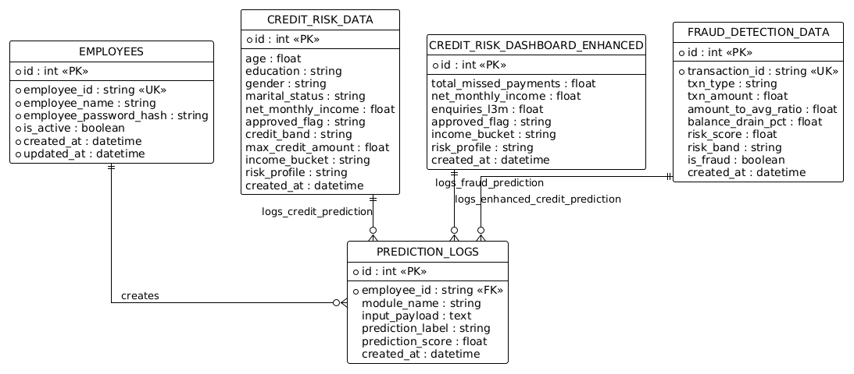
Figure 1. ERD Diagram
Entity Name | Primary Role | Key Attributes | Description
EMPLOYEES | User Management | employee_id (UK), employee_name, is_active | Stores staff credentials and status. Acts as the primary actor for all system activities.
CREDIT_RISK_DATA | Base Credit Analysis | age, net_monthly_income, risk_profile | Contains demographic and financial data used for standard creditworthiness assessments.
CREDIT_RISK_DASHBOARD_ENHANCED | Advanced Credit Metrics | total_missed_payments, enquiries_l3m | Tracks behavioral risk factors like payment history and recent credit inquiries.
FRAUD_DETECTION_DATA | Transaction Monitoring | transaction_id (UK), risk_score, is_fraud | Stores transactional behavior metrics to identify potentially fraudulent activity.
PREDICTION_LOGS | Centralized Audit Log | employee_id (FK), input_payload, prediction_score | A unified table that records every prediction, the input data used, and the staff member responsible.

3.2 Use Case Diagram
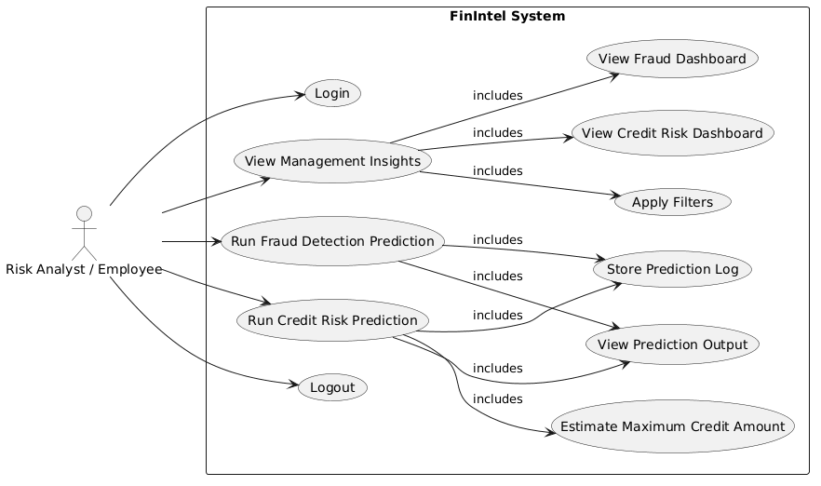
Figure 2. Use case Diagram
Description:
Category | Use Case | Description
Access Control | Login / Logout | The entry and exit points for the Analyst, ensuring secure access to financial data.
System Insights | View Management Insights | The primary dashboard entry point. It automatically includes the ability to view Credit Risk, Fraud Dashboards, and apply specific data filters.
Credit Operations | Run Credit Risk Prediction | A core analytical function that includes estimating maximum credit amounts, displaying the output, and automatically storing a prediction log.
Fraud Operations | Run Fraud Detection Prediction | A security-focused function that includes viewing the prediction results and generating an audit log for the action.
Reporting & Audit | View Prediction Output | A shared sub-process for both Credit and Fraud modules to display model results to the Analyst.
Data Integrity | Store Prediction Log | A background process triggered by predictions to ensure a permanent record is kept for compliance and auditing.

Use Case: Login Page
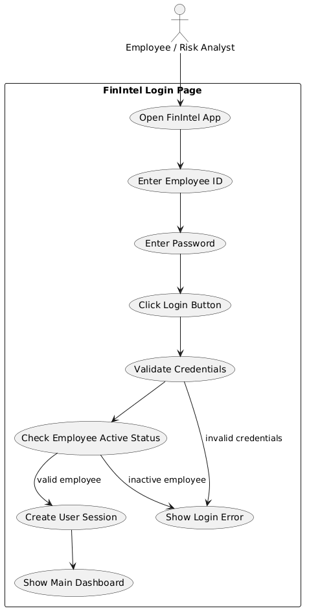

Figure 3. Login Page Diagram
Description:
Step | Use Case | Actor/System Role | Description
1 | Open FinIntel App | Employee | The initial entry point where the user accesses the application interface.
2 | Credential Entry | Employee | The user inputs their unique Employee ID and Password into the system.
3 | Click Login Button | Employee | The action that triggers the backend authentication sequence.
4 | Validate Credentials | System | The system verifies if the ID and password match the records in the database.
5 | Check Active Status | System | A security gate that ensures the employee account is not disabled or inactive.
6 | Session Creation | System | Upon successful validation and active status, the system creates a secure user session.
7 | Success Outcome | System | The user is redirected to the Main Dashboard to begin their work.
8 | Error Handling | System | Triggers a Login Error if credentials are incorrect or if the employee is marked as inactive.

Use Case: Management Insights
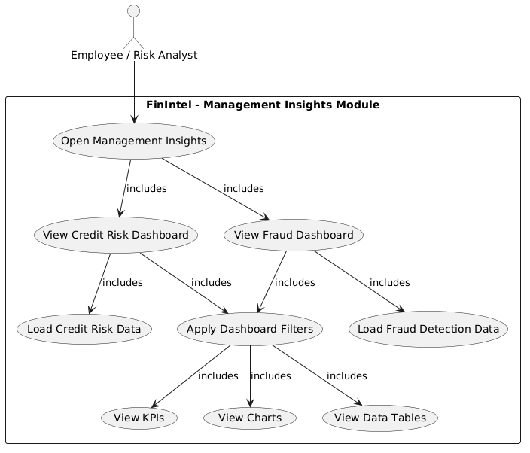
Figure 4. Management Insights
Description:
Feature Category | Use Case | Description
Navigation | Open Management Insights | The primary entry point for the Analyst. Accessing this module automatically includes loading both the Credit Risk and Fraud dashboards.
Domain Views | Credit & Fraud Dashboards | Two specialized views (UC2 & UC3) that provide high-level oversight of financial risk and fraudulent activity.
Data Integration | Load Module Data | Back-end processes (UC4 & UC5) that fetch raw datasets specifically required for either Credit Risk or Fraud analysis.
User Control | Apply Dashboard Filters | A central functionality (UC6) shared by both dashboards, allowing the Analyst to refine data based on specific parameters.
Visual Analytics | View KPIs, Charts, & Tables | The final output layer where filtered data is visualized as Key Performance Indicators, graphical charts, and detailed data tables for review.

Use Case: Credit Risk Prediction
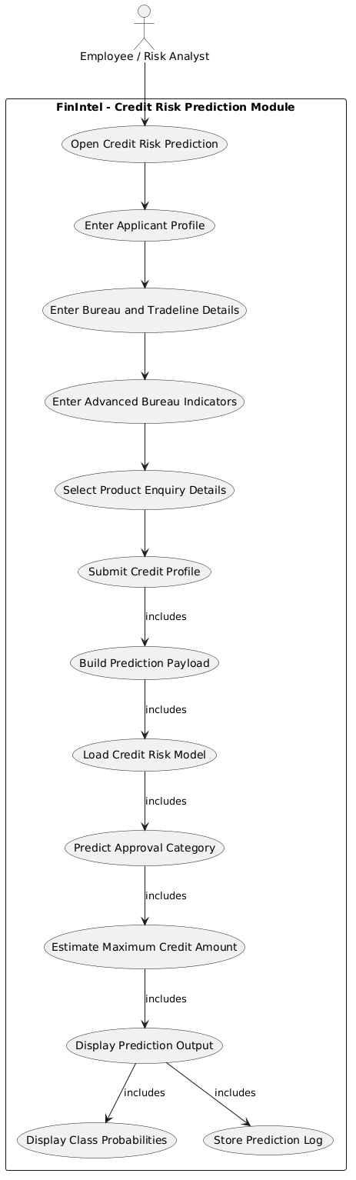
Figure 5. Credit Risk Prediction
Description:
Step | Use Case | Component Type | Description
1 | Open Credit Risk Prediction | User Initiation | The analyst accesses the specific prediction interface to start a new application review.
2 | Data Entry Phase | Input (UC2–UC5) | The user enters Applicant Profiles, Bureau/Tradeline details, Advanced Indicators, and specific Product Enquiry details.
3 | Submit Credit Profile | System Trigger | The user confirms the inputs, triggering the automated backend processing sequence.
4 | Build Prediction Payload | Data Processing | The system aggregates all user inputs into a structured format (JSON/Object) compatible with the ML model.
5 | Load Credit Risk Model | Model Execution | The specific machine learning artifact (e.g., a joblib file) is loaded into the system memory for inference.
6 | Predict & Estimate | Analytical Engine | The system determines the Approval Category (UC9) and calculates the Maximum Credit Amount (UC10).
7 | Display Results | Output Layer | The interface shows the final prediction (UC11) alongside specific Class Probabilities (UC12) for transparency.
8 | Store Prediction Log | Audit & Compliance | The system automatically records the transaction, input data, and model output in the database for auditing.

Use Case: Fraud Prediction
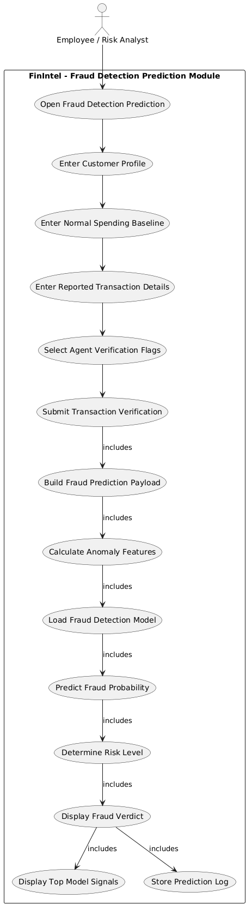
Figure 6. Fraud Prediction
Description:
Step | Use Case | Component Type | Description
1 | Open Fraud Detection Prediction | User Initiation | The Analyst launches the fraud analysis interface to evaluate a specific customer transaction.
2 | Data Entry Phase | Input (UC2–UC5) | The user inputs the Customer Profile, spending baselines, transaction specifics, and manual verification flags.
3 | Submit Transaction Verification | System Trigger | The user submits the gathered data, initiating the automated back-end evaluation process.
4 | Build Fraud Prediction Payload | Data Processing | The system structures the inputs into a specialized payload for the machine learning model.
5 | Calculate Anomaly Features | Feature Engineering | The system computes derived metrics (e.g., deviations from spending baselines) to identify unusual patterns.
6 | Load Fraud Detection Model | Model Execution | The system loads the fraud detection ML artifact into the environment for real-time inference.
7 | Predict & Determine Risk | Analytical Engine | The model calculates the Fraud Probability (UC10) and assigns a specific Risk Level (UC11).
8 | Display Verdict & Signals | Output Layer | The UI presents the final fraud verdict and highlights the Top Model Signals (UC13) that influenced the result.
9 | Store Prediction Log | Audit & Compliance | A permanent record of the inputs, features, and the model's verdict is saved to the database for auditing.

  - Activity Diagram: Risk Analyst

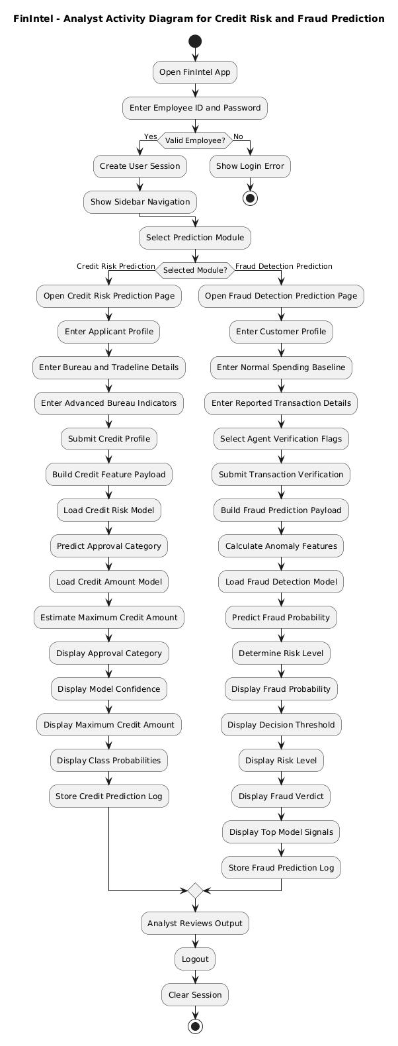
Figure 8. Activity Diagram Risk Analyst
Description:
Phase | Activity / Decision | Description
Authentication | Login & Validation | The user provides credentials. The system performs a security check; if successful, a User Session is created and the sidebar navigation is enabled.
Module Selection | Choose Prediction Type | The Analyst decides between two primary functional paths: Credit Risk Prediction or Fraud Detection Prediction.
Credit Risk Path | Data Entry & Inference | The Analyst inputs applicant and bureau data. The system builds a feature payload, loads two models (Approval and Amount), and outputs the Approval Category and Max Credit Amount.
Credit Output | Result Visualization | The system displays the final prediction results along with Model Confidence and Class Probabilities for a transparent "Human-in-the-Loop" review.
Fraud Detection Path | Data Entry & Feature Engineering | The Analyst inputs transaction and spending baseline details. The system calculates Anomaly Features and loads the fraud model to predict probability.
Fraud Output | Risk Assessment | The system presents the Fraud Probability, Risk Level, and Top Model Signals to help the Analyst understand the underlying indicators of the fraud verdict.
Data Integrity | Prediction Logging | Upon completion of either module, the system automatically Stores a Prediction Log for audit trails and regulatory compliance.
Termination | Review & Session Exit | The Analyst reviews the final outputs, performs a manual logout, and the system Clears the Session to maintain security.

3.4 Sequence Diagram:

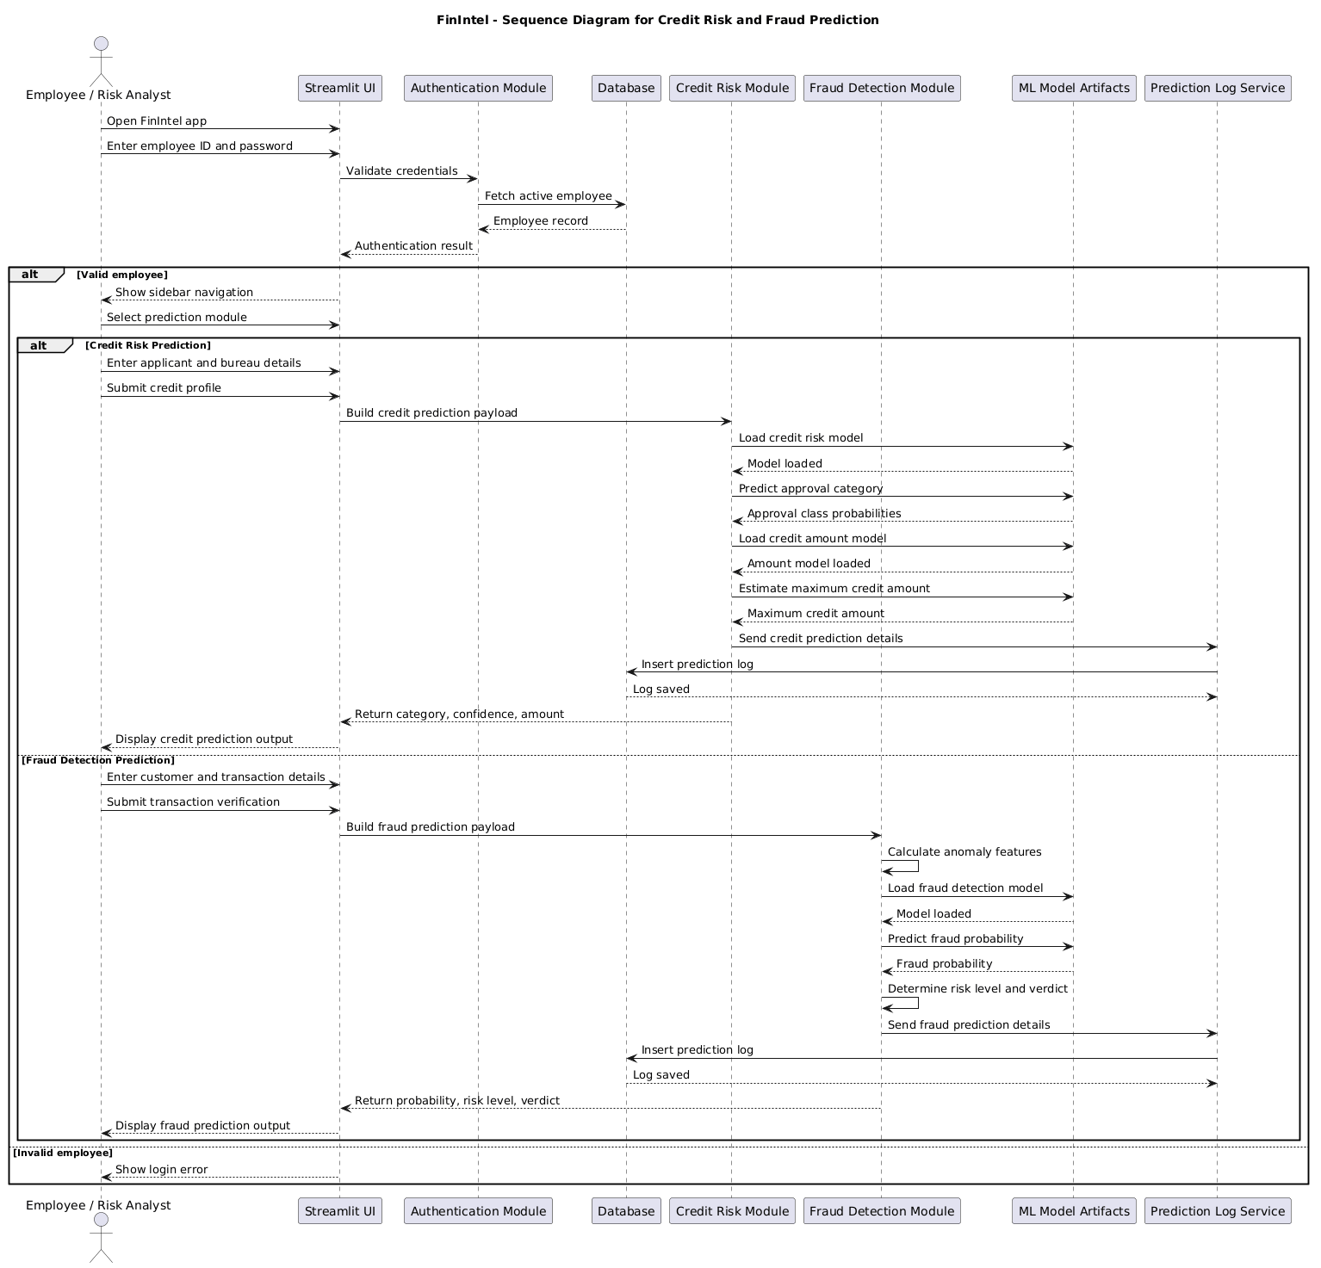
Figure 10. Sequence Diagram

Description
Phase | Interaction Sequence | Description
Authentication | Analyst → UI → Auth → DB | The Analyst provides credentials. The system queries the Database for an active record; upon verification, the UI unlocks the sidebar navigation.
Module Selection | Analyst → UI | The Analyst chooses between the Credit Risk or Fraud Detection functional paths within the interface.
Credit Logic | UI → Credit → Model | The Credit Module formats the input, loads the necessary ML artifacts from storage, and executes two separate inferences: Approval Category and Max Credit Amount.
Fraud Logic | UI → Fraud → Model | The Fraud Module performs feature engineering (anomaly calculation) and queries the model to generate a Fraud Probability and a human-readable Risk Level.
Audit Logging | Module → LogService → DB | Both modules asynchronously trigger the Log Service to persist the inputs and results into the Database, ensuring a permanent audit trail.
Response | Module → UI → Analyst | The backend returns calculated metrics (confidence, amounts, or verdicts) to the Streamlit UI for the final display to the Analyst.

3.5 Class Diagram: -
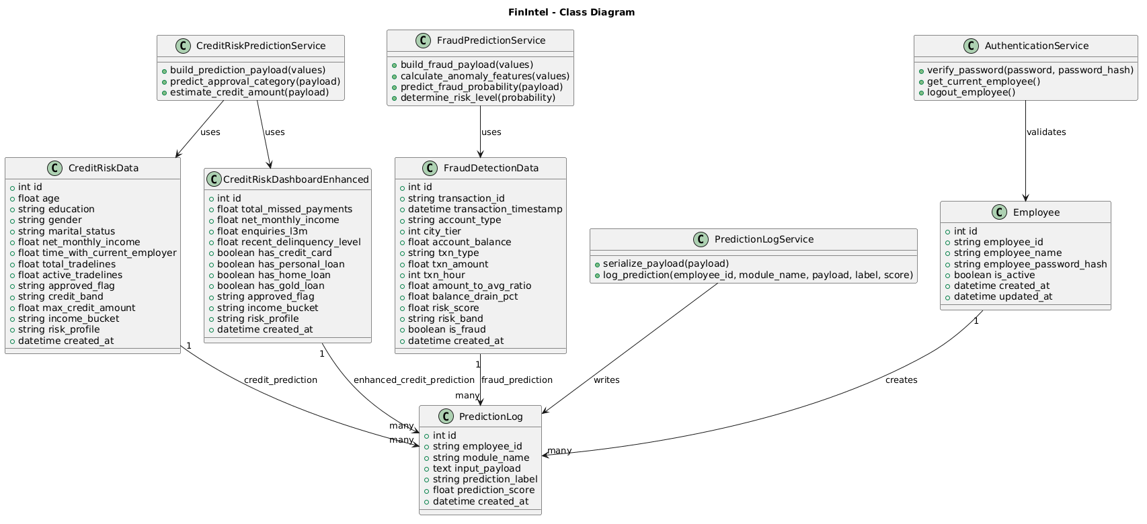
Figure 12. Class Diagram
Description
Class Name | Responsibility | Key Attributes
Employee | Manages user identity and access control. | employee_id, employee_password_hash, is_active
CreditRiskData | Stores standard applicant profiles and creditworthiness metrics. | net_monthly_income, credit_band, max_credit_amount
CreditRiskDashboardEnhanced | Tracks behavioral risk indicators and existing loan distributions. | total_missed_payments, enquiries_l3m, recent_delinquency_level
FraudDetectionData | Records transactional behavior and anomaly detection scores. | txn_amount, balance_drain_pct, risk_score, is_fraud
PredictionLog | Acts as the unified audit trail for all model inferences. | module_name, input_payload, prediction_label
Table: Data Entities (Models)

Service Name | Primary Operations | Description
AuthenticationService | verify_password(), get_current_employee() | Handles session security and credential verification.
CreditRiskPredictionService | predict_approval_category(), estimate_credit_amount() | Processes input payloads to determine loan eligibility and limits.
FraudPredictionService | calculate_anomaly_features(), predict_fraud_probability() | Engineered features from raw data to assess the likelihood of illicit activity.
PredictionLogService | serialize_payload(), log_prediction() | Formats and persists prediction data into the database for compliance.
Table: Functional Service Logic
Relationship | Type | Multiplicity | Description
Employee → PredictionLog | Directed Association | 1 to Many | One employee is responsible for generating multiple log entries.
Data Entities → PredictionLog | Dependency | 1 to Many | Credit and Fraud data records serve as the source material for specific logs.
Service → Entity | Dependency | Uses / Writes | Services perform logic on or for specific classes (e.g., LogService writes to PredictionLog).
Table: Class Relationship & Association

3.6 Module Hierarchy Diagram: -
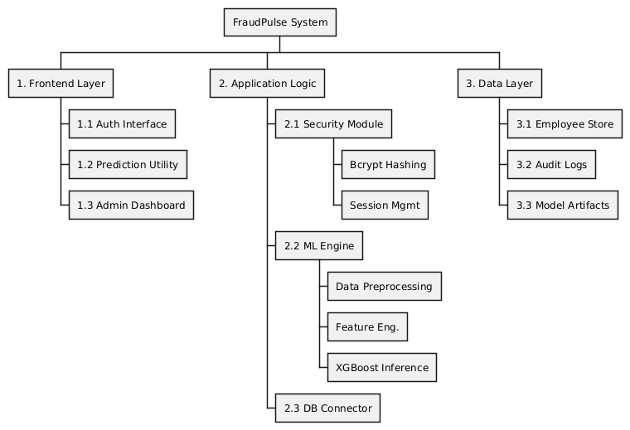
Figure 13. Module Hierarchy Diagram
Description

3.7 Table specifications (Database design)
The Fraud Pulse system utilizes a relational database SQLite to ensure data integrity and security. The schema consists of two primary tables: one for managing authorized personnel and another for logging all fraud prediction events.
Table: employees (User Management)
This table stores authentication details for all system users. To comply with security best practices, passwords are never stored in plain text; instead, a Bcrypt hash is stored.
Field Name | Data Type | Key / Constraint | Description
id | INTEGER | PRIMARY KEY, AUTO_INCREMENT | Unique identifier for each employee.
username | VARCHAR(50) | UNIQUE, NOT NULL | The username used for login authentication.
password_hash | VARCHAR(255) | NOT NULL | The secure hash string generated by the Bcrypt algorithm.
role | VARCHAR(20) | NOT NULL | Defines the user's privilege level (e.g., 'Analyst', 'Admin').
created_at | DATETIME | DEFAULT CURRENT_TIMESTAMP | The timestamp when the account was registered.

Table: prediction logs (Audit Trail)
This table acts as an immutable ledger, recording every single transaction analysed by the system. It is critical for regulatory compliance, forensic analysis, and monitoring model performance.
Field Name | Data Type | Key / Constraint | Description
log_id | INTEGER | PRIMARY KEY, AUTO_INCREMENT | Unique identifier for the log entry.
input_amount | DECIMAL(15,2) | NOT NULL | The monetary value of the transaction being checked.
transaction_type | VARCHAR(20) | NOT NULL | The category of transfer (e.g., 'TRANSFER', 'CASH_OUT').
risk_score | FLOAT | NOT NULL | The probability score (0.00 - 1.00) generated by the ML model.
prediction_class | VARCHAR(10) | NOT NULL | The final binary classification ('FRAUD' or 'SAFE').
checked_by | VARCHAR(50) | FOREIGN KEY | The username of the Analyst who performed the check.
timestamp | DATETIME | DEFAULT CURRENT_TIMESTAMP | The exact server time when the prediction was made.

3.8 Data Dictionary
The Data Dictionary below details the metadata, constraints, and validation logic for every data element within the Fraud Pulse database schema.
Table 3.7.1: User Identity Data Elements (Associated Table: employees)
Field Name | Data Type | Size | Key / Constraints | Description & Validation Logic
username | VARCHAR | 50 | UNIQUE, NOT NULL | The unique login ID for an Analyst or Admin. Validation: Must be alphanumeric; no spaces allowed.
password_hash | VARCHAR | 255 | NOT NULL | The Bcrypt encrypted string of the user's password. Security: Plain text passwords are never stored.
role | VARCHAR | 20 | NOT NULL | Defines the user's permission level. Domain Values: 'Analyst', 'Admin'.
created_at | DATETIME | N/A | DEFAULT CURRENT_TIMESTAMP | The server timestamp recording when the user account was created.
id | INTEGER | N/A | PRIMARY KEY, AUTO_INCREMENT | Internal system identifier for indexing users.

Table 3.7.2: Transaction & Audit Data Elements (Associated Table: prediction_logs)
Field Name | Data Type | Size | Key / Constraints | Description & Validation Logic
log_id | INTEGER | N/A | PRIMARY KEY, AUTO_INCREMENT | Unique ID for the specific audit record.
input_amount | DECIMAL | (15,2) | NOT NULL | The transaction value. Validation: Must be numeric and $\ge$ 0 (Negative values rejected by UI).
transaction_type | VARCHAR | 20 | NOT NULL | The banking channel used. Domain Values: CASH_OUT, TRANSFER, PAYMENT, CASH_IN, DEBIT.
risk_score | FLOAT | N/A | NOT NULL | The probability calculated by the ML model (0.00 to 1.00). Used to trigger UI alerts.
prediction_class | VARCHAR | 10 | NOT NULL | The categorical decision. Domain Values: 'FRAUD' (if score > 0.5), 'SAFE' (if score $\le$ 0.5).
checked_by | VARCHAR | 50 | FOREIGN KEY | The username of the Analyst who performed the check. Links back to employees.username.
timestamp | DATETIME | N/A | DEFAULT CURRENT_TIMESTAMP | Immutable. The exact server time of the prediction. Cannot be altered once written.

CHAPTER 4: USER MANUAL

4.1 User Interface Screens (Input):-
Login Page:

Figure 13 Secure Login Interface

Description
The Login Interface serves as the primary security gateway for the FraudPulse application. It allows authorized personnel (Risk Analysts and Administrators) to authenticate themselves before accessing sensitive financial data.
- Functionality: The user must enter their unique Username and Password. The "Login" button triggers a backend authentication sequence.
- Security:
  - Password Masking: The password field is masked (showing dots ••••) to ensure privacy during entry.
  - Bcrypt Validation: The system does not store plain-text passwords. Upon submission, the entered password is hashed and compared against the encrypted credentials stored in the PostgreSQL database.
- Error Handling: If the credentials do not match, the system displays a "Login Failed" error message, preventing unauthorized access to the system.

Description:
4.2 Output Screen Diagram
High-Risk Prediction (Fraud Alert):
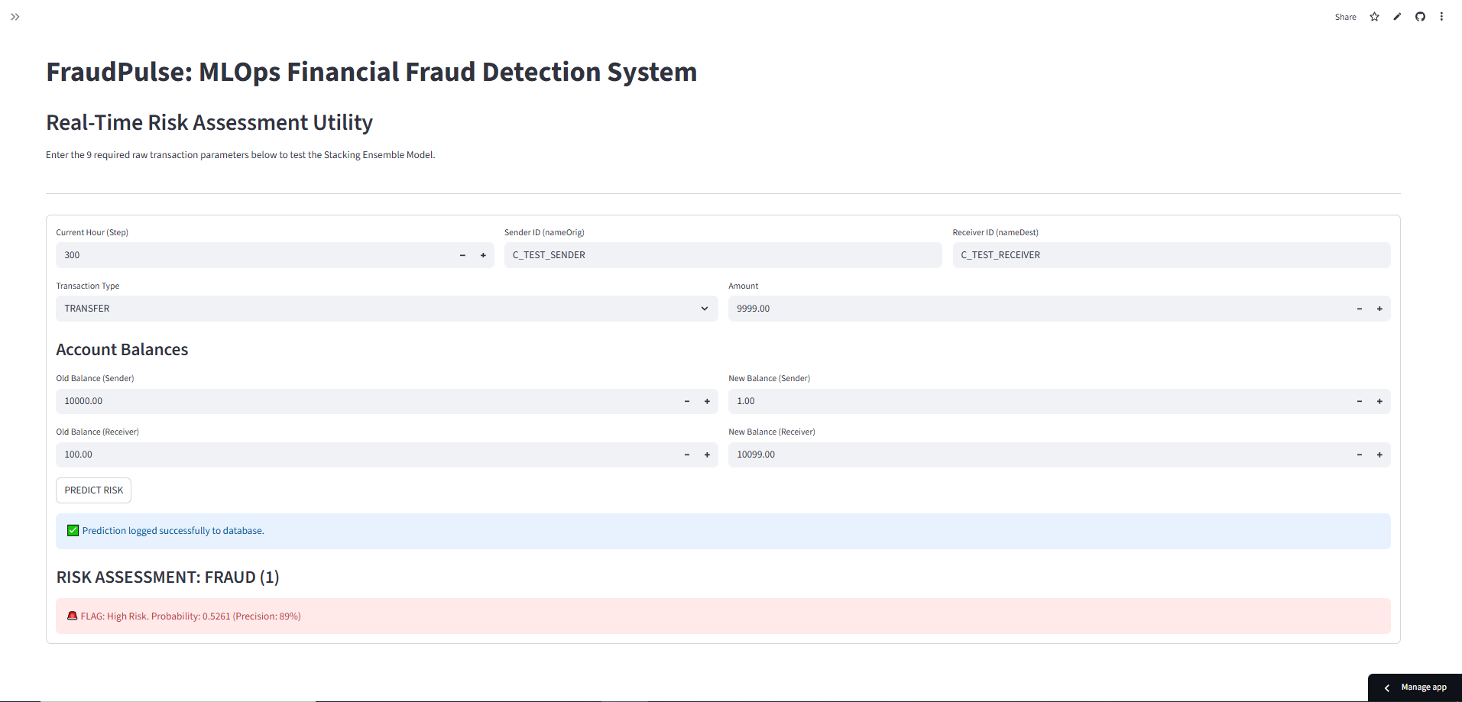
Figure 15. 1 High-Risk Fraud Alert Output

Description:
This screen displays the system's response when a transaction is flagged as Fraudulent.
- Visual Indicator: The interface uses a prominent Red Alert Box to instantly warn the Risk Analyst.
- Risk Score: The screen explicitly displays the calculated probability (e.g., "Probability: 0.98"). A score above the configured threshold (0.5) triggers this classification.
- Actionable Insight: This output serves as a decision support signal, instructing the analyst to immediately BLOCK the transaction and freeze the associated account to prevent financial loss.
Low-Risk Prediction (Safe Status)
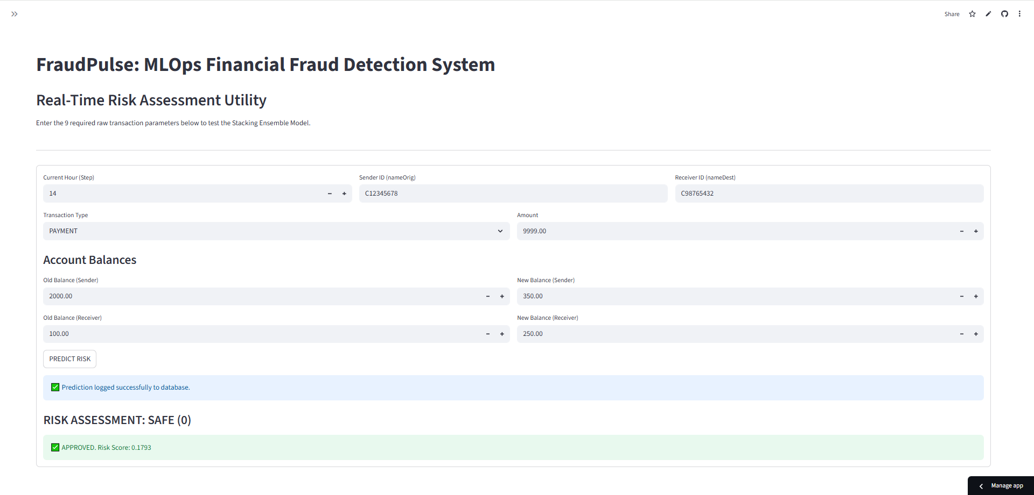
Figure 15.2 Low Risk Fraud Alert Output
Description:
This screen illustrates the system's response when a transaction is deemed Legitimate.
- Visual Indicator: A Green Success Message is displayed to confirm the safety of the transfer.
- Low Probability: The risk score is shown to be well below the threshold (e.g., "Probability: 0.02"), indicating no anomalous behavior was detected.
- Operational Efficiency: This output allows the analyst to quickly APPROVE the transaction, ensuring that genuine customers do not face unnecessary delays.
Performance Dashboard
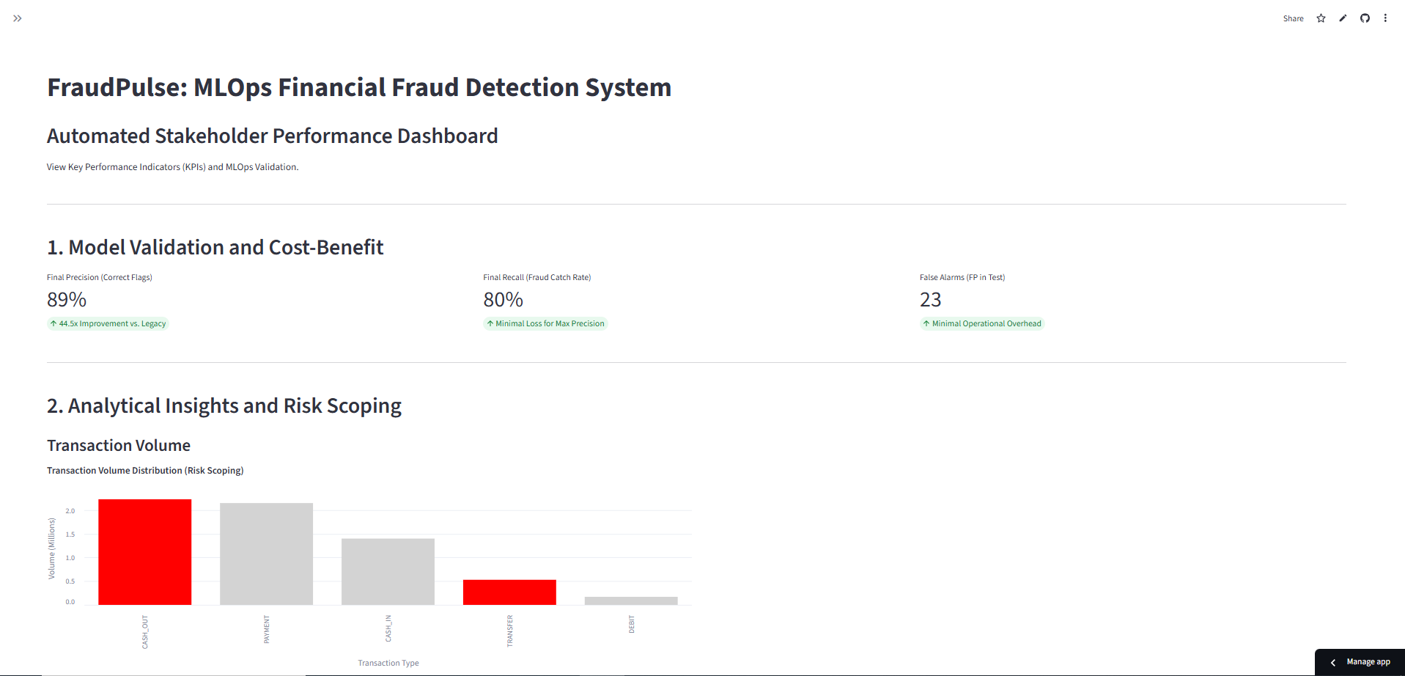
Figure 16.1 Stake Holder Performance Dashboard
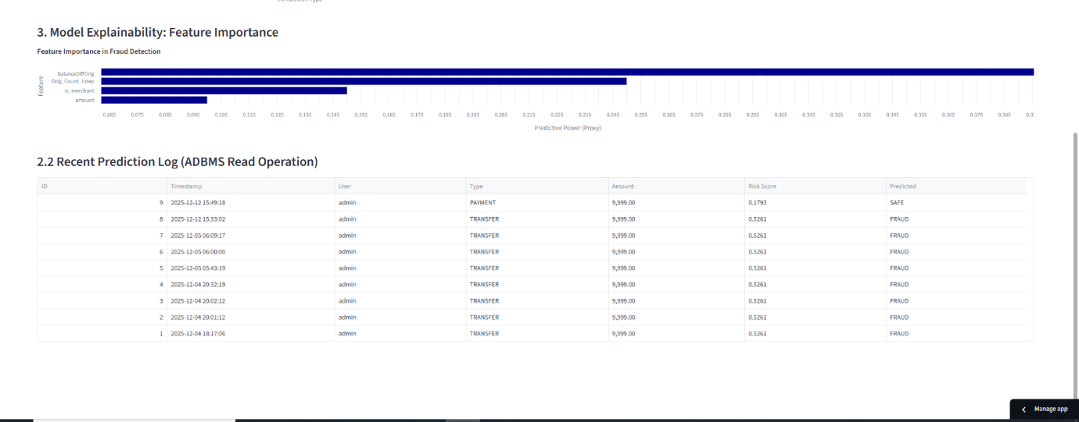
Figure 16.2 Employee Performance Dashboard

Description
The Governance Dashboard is the central oversight module designed exclusively for System Administrators and Risk Managers. Unlike the prediction utility which handles individual cases, this dashboard provides a holistic view of the system's performance and fraud trends over time.
- Technology Stack: The dashboard is powered by Altair, a declarative statistical visualization library for Python. It dynamically renders interactive charts directly from the live prediction_logs database table.
- Key Visualizations:
  - Fraud vs. Safe Distribution (Bar Chart):
    - Displays the total count of transactions processed.
    - Visually compares the ratio of "Safe" transactions (Green) against "Fraud" attempts (Red), allowing managers to gauge the current attack volume.
  - Model Performance Metrics:
    - Average Risk Score: Monitors the baseline risk level across all transactions.
    - Flag Rate: Tracks the percentage of total transactions that are being blocked. If this spikes unexpectedly, it may indicate a "False Positive" wave (Model Drift).
- Operational Value: This dashboard transforms raw data into actionable business intelligence, enabling stakeholders to make data-driven decisions about risk policy and model retraining schedules.

4.3 Data Reports:

Overview
The Data Reporting Module functions as the central repository for historical analysis. While the Prediction Utility (Section 4.1) handles real-time checks, the Data Report ensures that every single decision made by the AI is securely logged, indexed, and accessible for forensic review. This module is the primary tool used by System Administrators and Senior Auditors to validate model performance and investigate past security incidents.

4.3.2 Report Interface
Interface Description: The report renders a responsive data grid (powered by st.dataframe or AgGrid in Streamlit) that pulls records directly from the prediction_logs PostgreSQL table. The data is presented in reverse chronological order, ensuring the most recent transactions appear at the top.

4.3.3 Report Columns & Field Definitions
The report aggregates data from both the input layer and the inference engine. The key columns displayed in the audit trail are defined below:
Column Name | Source | Description
Log ID | Database | A sequential, unique identifier for the record. Useful for referencing specific cases in bug reports.
Timestamp | Server | The exact date and time (UTC) when the prediction occurred. This is immutable and serves as the legal proof of when the check happened.
Analyst (User) | Session | The username of the employee who initiated the check. This provides accountability.
Amount ($) | Input | The monetary value of the transaction.
Transaction Type | Input | The channel used (e.g., TRANSFER, CASH_OUT).
Risk Probability | ML Model | The raw confidence score (e.g., 0.982). This allows auditors to see "how close" a decision was to the threshold.
Final Status | Logic | The binary classification: <span style="color:red">FRAUD</span> or <span style="color:green">SAFE</span>.

Interactive Control Features
To manage the massive volume of transaction data (potentially millions of records), the Data Report module includes advanced filtering and export capabilities:
- Filter by Date Range:
  - Functionality: A calendar widget allows the admin to isolate transactions within a specific window (e.g., "Show me all checks from last weekend").
  - Use Case: Investigating a specific fraud attack wave that occurred on a holiday.
- Filter by Status (Fraud Only):
  - Functionality: A toggle switch or dropdown to hide "Safe" transactions and display only "Fraud" alerts.
  - Use Case: Auditors can focus exclusively on high-risk events without scrolling through legitimate traffic.
- Export to CSV / Excel:
  - Functionality: A "Download Data" button generates a .csv file of the current filtered view.
  - Use Case: This allows the data to be taken offline for further analysis in Excel, Tableau, or for submission to regulatory bodies (like RBI/Fed).

Backend Query Logic
When the report loads, the system executes an optimized SQL query to fetch the data efficiently:
SELECT
log_id,
timestamp,
checked_by,
input_amount,
risk_score,
prediction_class
FROM prediction_logs
ORDER BY timestamp DESC
LIMIT 100;

4.4 Sample Program Code:
App.py:
import streamlit as st
from config.settings import APP_NAME
from database.init_db import initialize_database
from modules.auth.login import render_login_page
from modules.auth.session_manager import get_current_employee, logout_employee
from modules.common.sidebar import render_sidebar
from modules.common.ui_helpers import inject_global_styles
from modules.dashboard.management_insights import render_management_insights
from modules.prediction.credit_risk import render_credit_prediction
from modules.prediction.fraud_detection import render_fraud_prediction
st.set_page_config(
page_title=APP_NAME,
page_icon="FI",
layout="wide",
initial_sidebar_state="expanded",
)
PAGE_RENDERERS = {
"Management Insights": render_management_insights,
"Credit Risk Prediction": render_credit_prediction,
"Fraud Detection Prediction": render_fraud_prediction,
}
def main() -> None:
initialize_database()
inject_global_styles()

employee = get_current_employee()
if not employee:
render_login_page()
return

selected_page = render_sidebar(employee)
if selected_page == "Logout":
logout_employee()
st.rerun()

PAGE_RENDERERS[selected_page]()
if __name__ == "__main__":
main()

4.5 Limitations: -

I. Data Integrity and Model Performance
The axiom "garbage in, garbage out" remains the primary hurdle in machine learning. Model quality is intrinsically linked to three data pillars:
- Quality: Data must be cleaned of noise, outliers, and errors that could skew the learning process.
- Freshness: As market conditions and user behaviors evolve, models must be retrained on recent data to prevent model drift, where predictive accuracy decays over time.
- Representativeness: The training set must mirror the actual environment in which the model operates. If the training data lacks diversity or fails to cover edge cases, the model will exhibit bias or fail when encountering real-world scenarios.

II. Infrastructure and State Management
Deploying on Streamlit Community Cloud offers rapid prototyping but introduces specific architectural limitations regarding data persistence.
- Ephemeral Storage: The platform’s local file system is wiped upon every reboot or update. Any data stored locally (e.g., SQLite files or local CSVs) will be lost.
- The External Solution: For production-grade applications, developers must use an external DATABASE_URL (connecting to services like PostgreSQL, MongoDB, or Snowflake) to ensure that user data and system states remain durable across sessions.

III. Deployment Optimization
Efficiency in the deployment pipeline is often hampered by heavy file sizes.
- Joblib Artifacts: While joblib is excellent for serializing large NumPy arrays and ML models, massive files significantly increase startup latency and can exceed deployment size limits.
- Best Practice: Streamline models through pruning, quantization, or by storing large artifacts in external cloud storage (like AWS S3) to be fetched only when necessary.

IV. Governance and Human-in-the-Loop
Machine learning should be viewed as an augmentation tool, not a replacement for professional judgment.
- Decision Support: Predictions provide probabilistic insights that help prioritize tasks or identify trends.
- Policy Review: Critical actions—especially those involving financial risk or personnel management—must undergo human or policy-based verification. This ensures that the system adheres to ethical standards and regulatory requirements that a model cannot inherently understand.

V. Environment Consistency
A common "silent killer" of ML systems is dependency drift.
- Artifact Compatibility: A model saved with specific versions of scikit-learn or pandas may fail to load or produce incorrect results if the production environment uses newer, incompatible versions.
- execution environment matches the environment used during the model's training phase.

4.6 Test Case:

Test Case ID | Scenario | Input | Expected Result
TC-01 | Valid login | Correct employee ID and password | User is authenticated and dashboard opens
TC-02 | Invalid login | Wrong password | Error message is shown
TC-03 | Logout | Click logout | Session is cleared and login screen appears
TC-04 | View management dashboard | Select Management Insights | Credit and fraud dashboard tabs are displayed
TC-05 | Credit prediction | Enter valid applicant and bureau details | Approval category, confidence, and credit amount are shown
TC-06 | Credit prediction logging | Submit credit prediction as logged-in user | Prediction entry is stored in prediction_logs
TC-07 | Fraud prediction | Enter valid transaction details | Fraud probability, risk level, and verdict are shown
TC-08 | Fraud prediction logging | Submit fraud prediction as logged-in user | Fraud prediction entry is stored in prediction_logs
TC-09 | Missing model artifact | Remove/disable model file | User-friendly missing model message is shown
TC-10 | Dashboard filters | Apply filters | Charts and tables update according to selected filters

Bibliography
[1] A. Géron, Hands-On Machine Learning with Scikit-Learn, Keras, and TensorFlow, 3rd ed. Sebastopol, CA: O'Reilly Media, 2023.
[2] S. Raschka and V. Mirjalili, Python Machine Learning: Machine Learning and Deep Learning with Python, Scikit-learn, and TensorFlow 2, 3rd ed. Birmingham, UK: Packt Publishing, 2019.
[3] A. C. Müller and S. Guido, Introduction to Machine Learning with Python: A Guide for Data Scientists. Sebastopol, CA: O'Reilly Media, 2017.
[4] Streamlit Documentation (Version 1.42.0). [Online]. Available: https://docs.streamlit.io/ (Primary framework used for Frontend and Dashboard development).
[5] XGBoost Documentation (Version 2.0.3). [Online]. Available: https://xgboost.readthedocs.io/en/stable/ (Core Gradient Boosting algorithm used for the fraud detection model).
[6] SQLAlchemy Documentation (Version 2.0). [Online]. Available: https://docs.sqlalchemy.org/ (ORM used for secure database interactions and SQL injection prevention).
[7] Passlib & Bcrypt Documentation. [Online]. Available: https://passlib.readthedocs.io/en/stable/lib/passlib.hash.bcrypt.html (Library used for secure password hashing and authentication).
[8] Scikit-learn User Guide (Version 1.4). [Online]. Available: https://scikit-learn.org/stable/user_guide.html (Used for Pipeline construction, Feature Engineering, and Random Forest implementation).
[9] Altair Visualization Library. [Online]. Available: https://altair-viz.github.io/ (Used for generating interactive charts in the Governance Dashboard).
[10] Pandas Documentation (Version 2.2). [Online]. Available: https://pandas.pydata.org/docs/ (Used for data manipulation and preprocessing of the 6.3 million record dataset).

References
[1] I. Emmanuel, Y. Sun, and Z. Wang, “A machine learning-based credit risk prediction engine system using a stacked classifier and a filter-based feature selection method,” Journal of Big Data, vol. 11, no. 23, Feb. 2024, doi: 10.1186
[2] J. O’Keefe, “The Use of Machine Learning for Credit Risk Assessment,” SSRN, May 2024, revised Dec. 2024, doi: 10.2139/ssrn.4835192.
[3] J. Quan and X. Sun, “Credit risk assessment using the factorization machine model with feature interactions,” Humanities and Social Sciences Communications, vol. 11, no. 234, Feb. 2024, doi: 10.1057/s41599-024-02700-7.
[4] T. T. M. Bui and Q. B. Ta, “An interpretable decision tree ensemble model for imbalanced credit scoring datasets,” Journal of Intelligent & Fuzzy Systems, vol. 45, no. 6, pp. 10095–10112, Sep. 2023, doi: 10.3233/JIFS-230825
[5] Y. Shen, H. Bao, Y. Feng, and Y. Dai, “Online credit default prediction model based on fusion of Random Forest and XGBoost algorithm,” in Proc. 2023 IEEE 3rd International Conference on Information Technology, Big Data and Artificial Intelligence (ICIBA), 2023, doi: 10.1109/ICIBA56860.2023.10165530.
[6] W. Wang, X. Zuo, and D. Han, “Predict credit risk with XGBoost,” Applied and Computational Engineering, vol. 74, no. 1, pp. 164–177, Jul. 2024, doi: 10.54254/2755-2721/74/20240462.
[7] T. Li and J. Zhou, “Evaluating the Effectiveness of Machine Learning Algorithms for Financial Fraud Detection,” Frontiers in Artificial Intelligence and Applications, Nov. 2024, doi: 10.3233/FAIA241178.
[8] N. J. Sarna, A. A. Singh, and S. S. Kumar, “Fraud Detection in Financial Domain using Machine Learning,” in Proc. 2023 International Conference on Computer Communication and Informatics (ICCCI), IEEE, Jan. 2023, pp. 1–5.
[9] R. Kumar and S. Singh, “Optimizing Credit Card Fraud Detection: Random Forest and XGBoost Ensemble,” in Proc. 2024 International Conference on Advances in Computing Research (ACROSET), IEEE, Sep. 2024, pp. 1–6.
[10] S. Lalchand, V. Srinivas, B. Maggiore, and J. Henderson, “Generative AI is expected to magnify the risk of deepfakes and other fraud in banking,” Deloitte Insights, May 2024.
[11] A. Kremer, A. Govindarajan, H. Singh, and I. Kristensen, “Embracing generative AI in credit risk,” McKinsey & Company, Jul. 2024. generative-ai-in-credit-risk
[12] A. Kremer, A. Govindarajan, H. Singh, and I. Kristensen, “Banking on gen AI in the credit business: The route to value creation,” McKinsey & Company, Jul. 2025

